**Ex.no:5**

**Date:4/4/25**

**5. Write a Servlet to demonstrate the difference between HTTP GET and POST**

**By creating a form and handling requests accordingly**

**Aim:**

To Write a Servlet to demonstrate the difference between HTTP GET and POST

By creating a form and handling requests accordingly .

**Program:**

**Sigh.html:**

<!DOCTYPE html>

<html>

<head>

<meta charset=*"ISO-8859-1"*>

<title>Sign-Up Page</title>

</head>

<body>

<center>

<h1>Sign-Up Page</h1>

<form method=*"post"* action=*"http://localhost:7750/Dynamic_web_project_muthulakshmi/SignupDetails"*>

<p>

<label for=*"Firstname"*>First name :</label>

<input type=*"text"* name=*"Firstname"* placeholder=*"Enter your Firstname"* >

</p>

<p>

<label for=*"Lastname"*>Last name :</label>

<input type=*"text"* name=*"Lastname"* placeholder=*"Enter your Lastname"* >

</p>

<p>

<label for=*"dob"*>Date of Birth:</label>

<input type=*"date"* id=*"dob"* name=*"dob"* required>

</p>

<p>

<label for=*"male"*>Gender : Male</label>

<input type=*"radio"* id=*"male"* name=*"gender"* value=*"male"*>

<label for=*"female"*>Female</label>

<input type=*"radio"* id=*"male"* name=*"gender"* value=*"female"*>

</p>

<p>

<label for=*"address"*>Address</label>

<textarea type=*"text"* name=*"address"*></textarea>

</p>

<input type=*"submit"* value=*"SignUp"*>

</form>

</center>

</body>

</html>

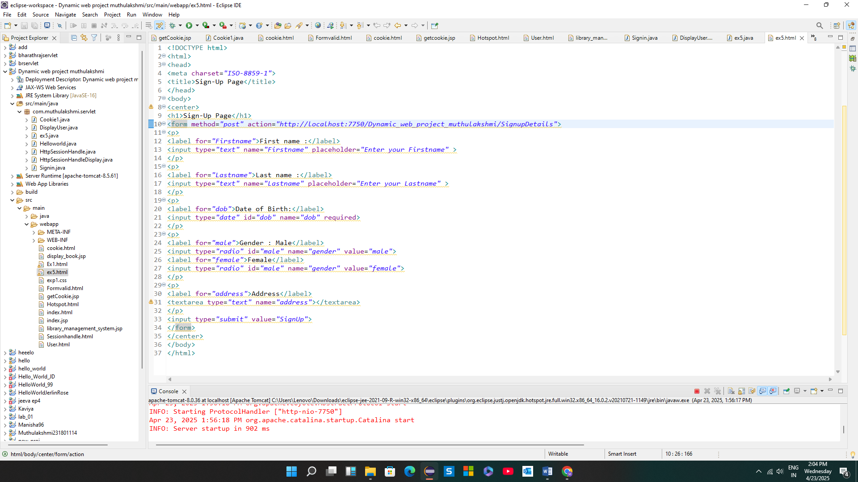

**PostGet.java**

package com.muthulakshmi.servlet;

import java.io.IOException;

import java.io.PrintWriter;

import javax.servlet.ServletException;

import javax.servlet.annotation.WebServlet;

import javax.servlet.http.HttpServlet;

import javax.servlet.http.HttpServletRequest;

import javax.servlet.http.HttpServletResponse;

/**

* Servlet implementation class SignupDetails

*/

@WebServlet("/SignupDetails")

public class ex5 extends HttpServlet {

private static final long serialVersionUID = 1L;

/**

* @see HttpServlet#HttpServlet()

*/

public ex5() {

super();

// TODO Auto-generated constructor stub

}

/**

* @see HttpServlet#doGet(HttpServletRequest request, HttpServletResponse response)

*/

protected void doGet(HttpServletRequest request, HttpServletResponse response) throws ServletException, IOException {

// TODO Auto-generated method stub

response.getWriter().append("Served at: ").append(request.getContextPath());

}

/**

* @see HttpServlet#doPost(HttpServletRequest request, HttpServletResponse response)

*/

protected void doPost(HttpServletRequest request, HttpServletResponse response) throws ServletException, IOException {

String f_name=request.getParameter("Firstname");

String l_name=request.getParameter("Lastname");

String dob_v=request.getParameter("dob");

String gen=request.getParameter("gender");

String add=request.getParameter("address");

PrintWriter p = response.getWriter();

p.println("First Name: "+f_name+"<br>");

p.println("Last Name: "+l_name+"<br>");

p.print("Age: "+dob_v+"<br>");

p.print("Gender: "+gen+"<br>");

p.print("Address: "+add+"<br>");

}

**Output:**

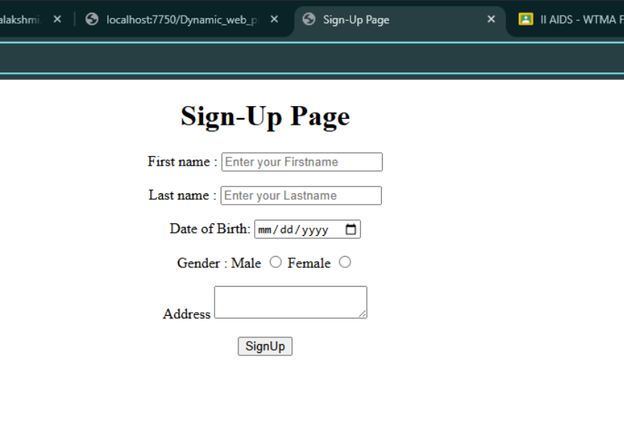

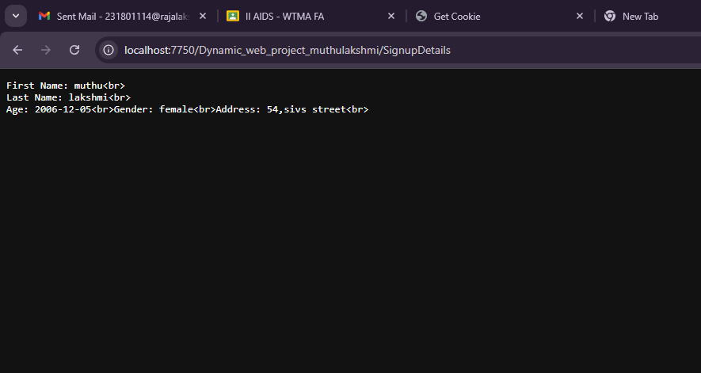

**Result:**

Thus the program was executed successfully on web browser and Servlet to demonstrated the difference between HTTP GET and POST By creating a form and handling requests accordingly